Media release:6 June 2022
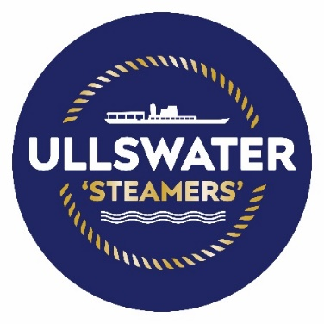
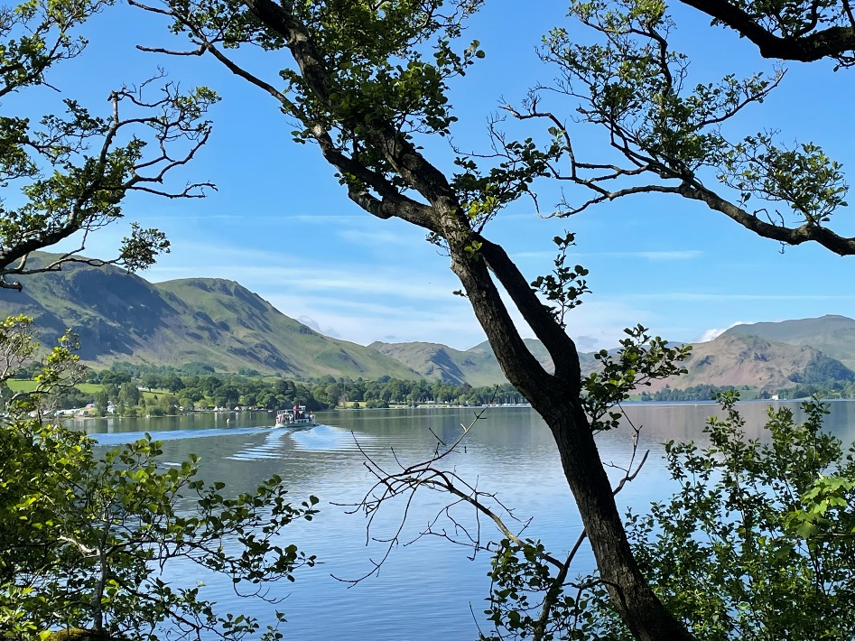
Summer gin tasting cruises coming to Ullswater

A gin experience like no other is coming to Ullswater in the Lake District this summer, as the Ullswater ‘Steamers’ has announced the return of their popular gin tasting evening cruises.

This year Ullswater ‘Steamers’ has teamed up with Chestnut House in Pooley Bridge to bring special tastings from UK artisan gin makers. Each evening cruise will focus on a different award-winning artisan distillery including tastings from Solway Spirits, Bedrock Gin, Shed 1 Distillery and Cuckoo Gin from Brindle Distillery.

The first Summer Gin Cruise kicks off this weekend on Friday 10 June and features ‘Lakeland Moon Gin’ from Pennington’s Distillery in Kendal, with its unique blend of wild juniper and other botanicals which have been gathered from the Lakeland Fells under the full moon.

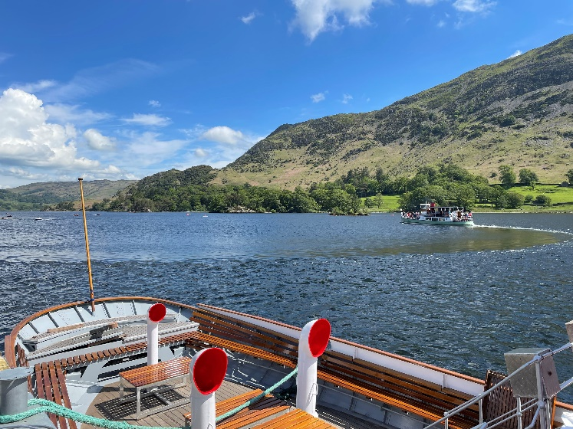
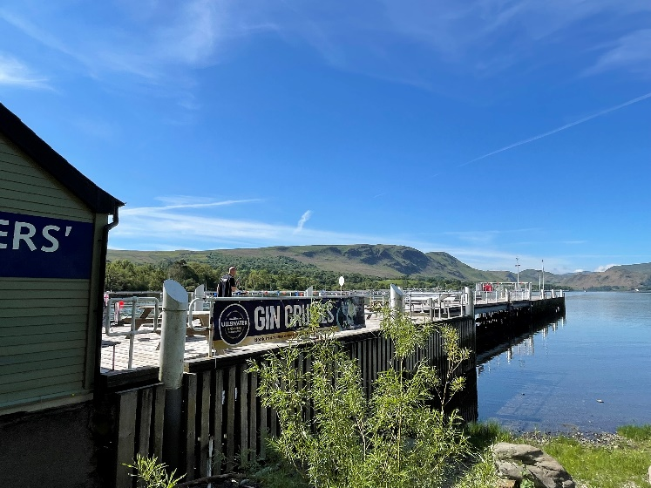
Setting sail at 7pm from Pooley Bridge, the Summer Gin Evenings will cruise across the length of Ullswater, allowing guests to enjoy the summer rays and spectacular Lakeland views from onboard the heritage ‘Steamers’, whilst sampling complex and unique gin flavours.

Cruises are scheduled to take place on Friday 10th, 17th, and 24th June, and 2nd, 9th September and take approximately 2 hours before returning to Pooley Bridge:
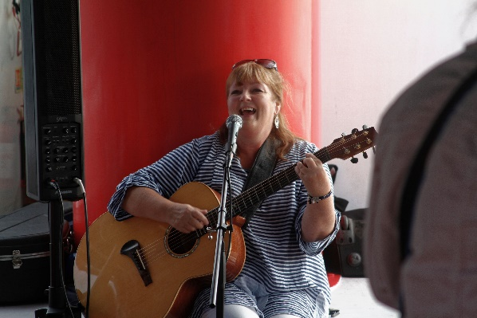
Live musical entertainment will complete the relaxed summer atmosphere, with local singer Fiona Hanlon, who has a repertoire of over 1000 songs covering pop, rock, country, folk, blues and jazz.

Rachel Bell, Head of Marketing says, ‘Our gin cruises are always so well received, what could be better than spending a beautiful summer evening cruising across the sparkling waters of Ullswater while enjoying a unique gin tasting experience. We are delighted to be working with Chestnut House this year to bring a selection of the finest UK made gins to our tasting evenings.”

More details about the summer gin cruises and how to book can be found at
www.ullswater-steamers.co.uk/events/gin-cruise

Event dates are as follows:
- 10th June Penningtons Kendal, Lakeland Moon Gin
- 17th June Solway Spirits, Annan
- 24th June Shed 1 Distillery, Ulverston
- 2nd Sept Cuckoo, Brindle distillery
- 9th Sept Bedrock Gin, Thornthwaite

[ENDS]

Notes to Editors:

Press contact Holly Collins, Cumbria Tourism Bespoke PR –
hcollins@cumbriatourism.org / 07398 255654

Ullswater ‘Steamers’ is a family-owned business that has been operating in the tranquil Ullswater Valley since 1859. Today, the company provides a sustainable and environmentally friendly way of linking some of the most iconic walking routes and views in the Lake District National Park. Ullswater ‘Steamers’ has one of the largest heritage passenger vessel fleets in England, including the oldest working passenger vessel in the world, Lady of the Lake.

Event Listing details:
Summer Gin Cruises ~
A Gin experience like no other! A special tasting with Chestnut House, focussing on a different UK gin distillery for each event date. There will also be entertainment onboard with Fiona Hanlon to complete the atmosphere. Dogs not permitted.
Dates: Fridays - 10th, 17th,24th June and 2nd & 9th September
Timings: Departs 7pm returns approx. 9pm.
Departure Point: Pooley Bridge pier
Ticket Price: £29.50 www.ullswater-steamers.co.uk/events/gin-cruise

